**Intelligent Systems**

**Exercise 4. Algorithms for   
Uninformed Search**

# Exercise description

The objective of this exercise is to apply the different blind search algorithms to find the route that would take an agent from an initial state to a goal state.

**Team members**

Write the student id, name, and campus of each member in a different line.

1:

2:

3:

**Search Space**

Consider the following weighted graph that describes the space of states (nodes) and actions (arcs) for a simple problem:

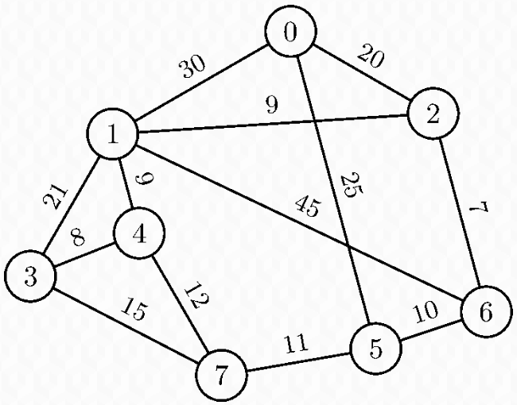

**Instructions**

* For each problem, you must draw a search tree showing all generated nodes.
* Every visited node must show a number indicating its order in the sequence of expansions (starting at 1).
* Generated but not visited nodes must not be numbered.
* Siblings (nodes generated from the same parent node) must be drawn and visited (if the algorithm does not say something else) from left to right according to their node number. For example, after expanding the node 4, node 1 must be drawn to the left of node 3, which, in turn, must be drawn to the left of node 7. The visiting order to these siblings, if the algorithm does not decide differently, must be from left to right.
* In each case, clearly show the solution found (path from the initial state to the goal state) and its path cost.
* Cross out every eliminated node.

**Problems**

1. **Breadth-first search**

*Find the solution for reaching the* ***goal state 7*** *from the* ***initial state 0*** *by breadth-first search with a* ***tree-search algorithm****.*

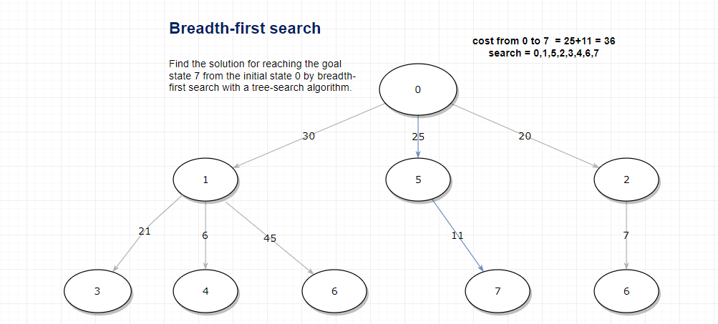

1. **Uniform-cost search**

*Find the solution for reaching the* ***goal state 3*** *from the* ***initial state 0*** *by uniform-cost search with a* ***graph-search algorithm****. In this case, additionally to the expansion order, every generated node must indicate its accumulated cost.*

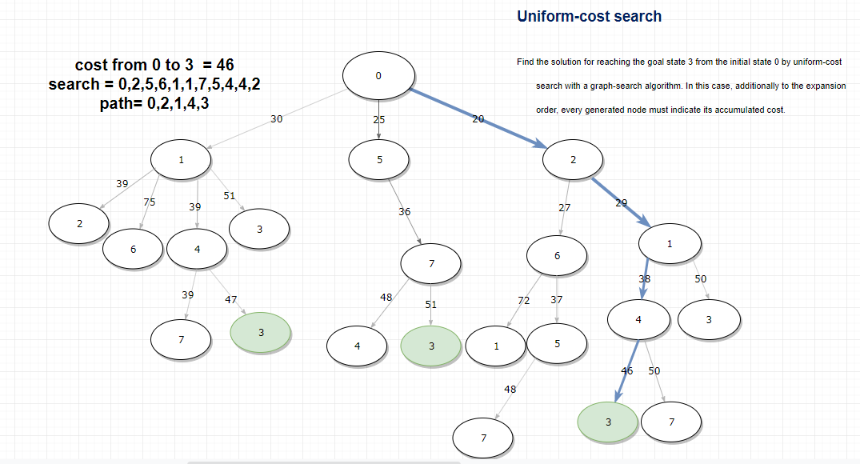

1. **Depth-first search**

*Find the solution for reaching the* ***goal state 3*** *from the* ***initial state 0*** *by depth-first search with a* ***graph-search algorithm****.*

1. **Iterative deepening depth-first search**

*Find the solution for reaching the* ***goal state 7*** *from the* ***initial state 0*** *by iterative deepening depth-first search with a* ***tree-search algorithm****. In this case, every node must have a list of visits since it can be visited several times during the search.*